PHYSICAL EDUCATION STUDIES

**YEAR 11 GENERAL**

**Functional Anatomy**

**2019**

**Question/Answer Booklet**

Name: ____________________________________

**Task weighting: 8%**

***Time allowed for this paper***

Reading/planning time before commencing work: Five minutes

Working time for paper: Fifty minutes

|  |  |
| --- | --- |
| ***Material required/recommended for this paper***  **To be provided by the supervisor**  This Question/Answer booklet  Sections One and Two: Write your answers in this Question/Answer booklet.  Spare lined paper  **To be provided by the candidate**  Standard items:Pens, pencil, eraser, correction fluid, highlighter, ruler |  |

***Important note to candidates***

No other items may be taken into the examination room. It is **your** responsibility to ensure that you do not have any unauthorised notes or other items of a non-personal nature in the examination room. If you have any unauthorised material with you, hand it to the supervisor **before** reading any further. All electronic devices are **NOT** permitted to be used unless arranged prior with the teacher. Students caught using electronic devices will automatically be given zero marks for the test.

***Structure of this paper***

|  |  |  |  |  |
| --- | --- | --- | --- | --- |
| Section | Number of questions available | Number of questions to be attempted | Suggested working time  (minutes) | Marks available |
| Section One:  Short Answer | 15 | 15 | 40 | 36 |
| Section Two:  Extended Answer | 1 | 1 | 10 | 9 |
|  |  |  | Total Marks | 45 |

**Instructions to candidates**

1. The rules for the conduct of this exam have been outlined. Sitting this examination implies that you agree to abide by these rules.

2. Answer all questions according to the following instructions.

3. You must be careful to confine your responses to the specific questions asked and to follow any instructions that are specific to a particular question.

4. Spare pages are included at the end of this booklet. They can be used for planning your responses and/or as additional space if required to continue an answer.

* Planning: If you use the spare pages for planning, indicate this clearly at the top of the page.
* Continuing an answer: if you need to use the space to continue an answer, indicate in the original answer space where the answer is continued, i.e. give the page number. Fill in the number of the question(s) that you are continuing to answer at the top of the page

**Section One: Short Answer (36 marks)**

1. Describe two (2) functions for the circulatory system (2 Marks)
2. __________________________________________________________________________________________________________________________________________
3. __________________________________________________________________________________________________________________________________________
4. Identify the three (3) structures labeled below on the heart. (3 Marks)

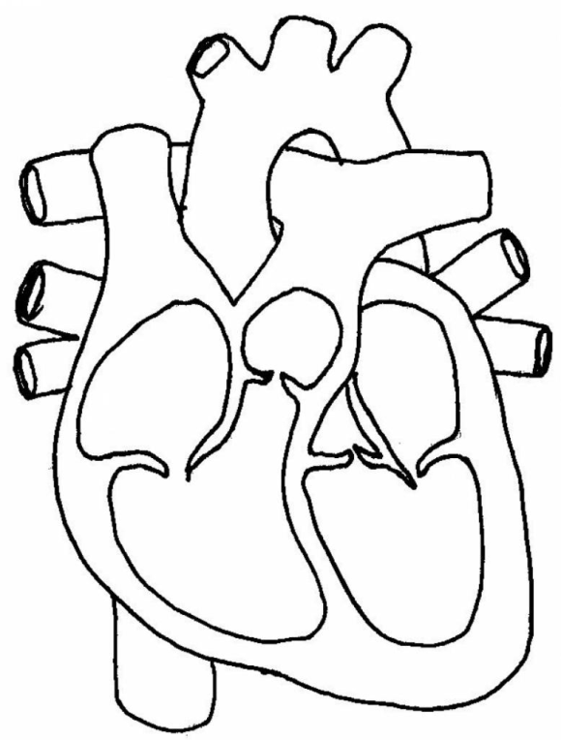

1. Identify the name of each anatomical plane described below:
2. The plane that divides the body into a left and right section

____________________________

1. The plane that divides the body into a top and bottom section

__________________________

1. The plane that divides the body into a front and back section

___________________________

(3 marks)

1. Identify structures four (4), eight (8) and eleven (11) labeled below on the respiratory system.

(3 Marks)

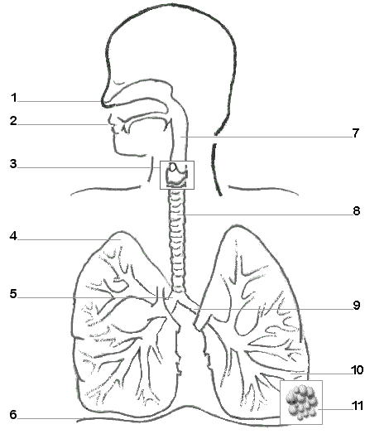

1. Describe two (2) functions for the respiratory system (2 Marks)
2. ____________________________________________________________________________________________________________________________________________
3. ____________________________________________________________________________________________________________________________________________
4. Choose two structures from the image above and briefly explain its function. (4 marks)

_______________________________________________________________________________________________________________________________________________________________________________________________________________________________________________________________________________________________________________________________________________________________________________________

1. Describe two (2) functions of the skeletal system (2 Marks)
2. ____________________________________________________________________________________________________________________________________________
3. ____________________________________________________________________________________________________________________________________________
4. Describe the difference between a short bone and an irregular bone. Provide an example for each. (4 marks)

________________________________________________________________________________________________________________________________________________________________________________________________________________________________________________________________________________________________

1. Identify the three (3) structures below on the skeletal system. (3 Marks)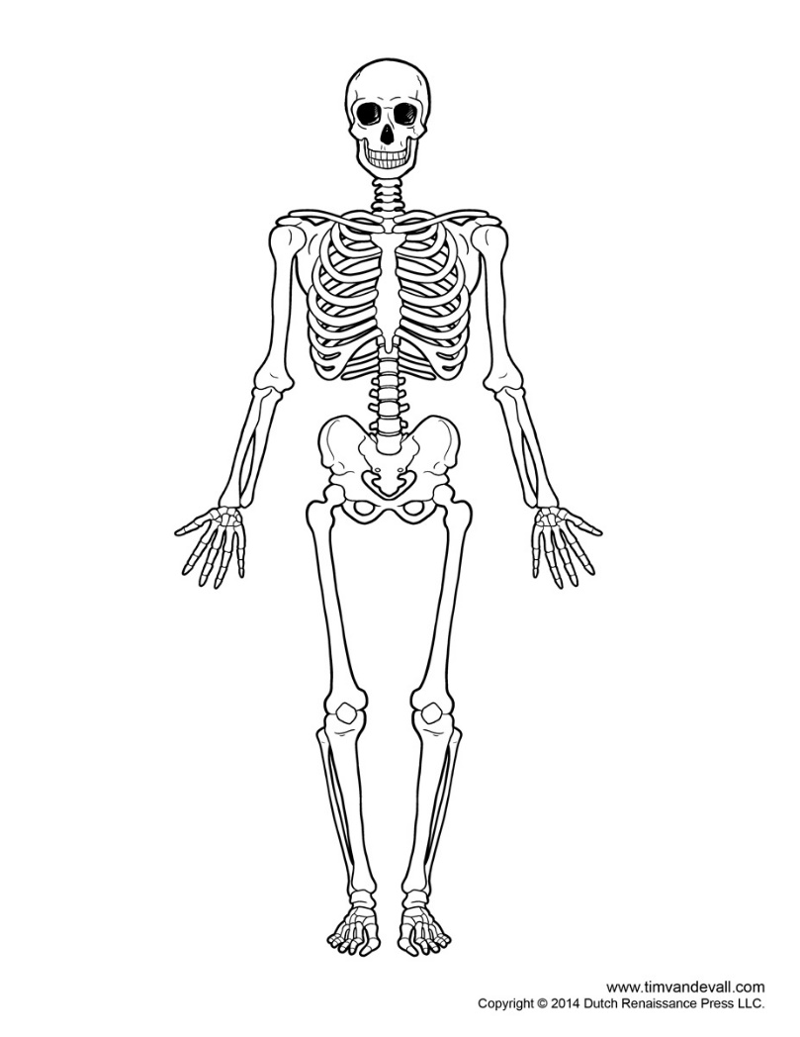
2. Describe two (2) functions of the muscular system (2 Marks)
3. __________________________________________________________________________________________________________________________________________
4. __________________________________________________________________________________________________________________________________________
5. What are the three types of muscles? (3 Marks)
6. ________________________________
7. ________________________________
8. ________________________________
9. Identify the three (3) structures below on the muscular system. (3 Marks)

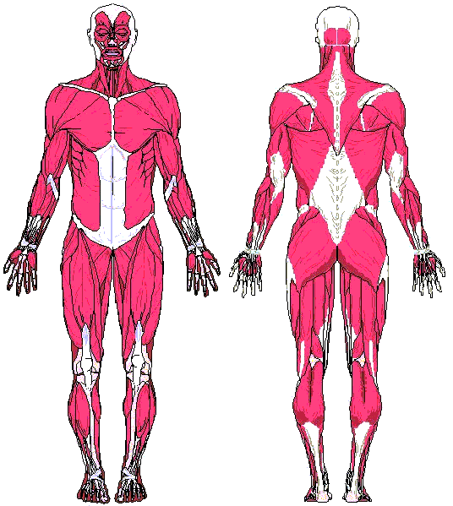

1. Explain the difference between flexion of the arm and extension of the arm. (2 Marks)

________________________________________________________________________________________________________________________________________________________________________________________________________________________

**Section Two: Extended Answer (9 marks)**

1. State the three somatotypes and describe the appearance of a person for each body type.

(9 marks)

_____________________________________________________________________________________________________________________________________________________________________________________________________________________________________________________________________________________________________________________________________________________________________________________________________________________________________________________________________________________________________________________________________________________________________________________________________________________________________________________________________________________________________________________________________________________________________________________________________________________________________________________________________________________________________________________________________________________________________________________________________________________________________________________________________________________________________________________________________________________________________________________________________________________________________________________________________________________________________________________________________________________________________________________________________________________________________________________________________________________________________________________________________________________________________________________________________________________________________________________________________________________________________________________________________________________________________________________________**END OF TEST**

**SPARE PAGE**

________________________________________________________________________________________________________________________________________________________________________________________________________________________________________________________________________________________________________________________________________________________________________________________________________________________________________________________________________________________________________________________________________________________________________________________________________________________________________________________________________________________________________________________________________________________________________________________________________________________________________________________________________________________________________________________________________________________________________________________________________________________________________________________________________________________________________________________________________________________________________________________________________________________________________________________________________________________________________________________________________________________________________________________________________________________________________________________________________________________________________________________________________________________________________________________________________________________________________________________________________________________________________________________________________________________________________________________________________________________________________________________________________________________________________________________________________________________________________________________________________________________________________________________________________________________________________________________________________________________________________________________________________________________________________________________________________________________________________________________________________________________________________________________________________________________________________________________________________________________________________________________________________________________________